**IN254M1**

**Competency Assessment**

**Kern Grant**

March 1st, 2025

**Introduction**

This document illustrates the designing of a program that converts temperature from Fahrenheit to Celsius and Kelvin. The methods used in this process are Input Process Output (IPO) Chart, Flowchart, Pseudocode, and Desk Check Analysis. The temperature conversion formulas used in this process are:

1. Fahrenheit to Celsius Formula:

* C = (F - 32) × 5/9**

1. Fahrenheit to Kelvin Formula:

* K = (F - 32) × 5/9 + 273.15

**Input – Process-Output (IPO) Chart**

The IPO chart below outlines the temperature conversion program's inputs, processes, and outputs.

|  |  |  |
| --- | --- | --- |
| **Input** | **Process** | **Output** |
| Fahrenheit temperature entered by the user | Convert Fahrenheit to Celsius using the formula: **(Fahrenheit - 32) × 5/9** | Temperature in Celsius |
| Fahrenheit temperature entered by the user | Convert Fahrenheit to Kelvin using the formula: **(Fahrenheit - 32) × 5/9 + 273.15** | Temperature in Kelvin |

**Flowchart**

The flowchart below visually represents the step-by-step logic used to convert a Fahrenheit temperature into its Celsius and Kelvin equivalents.

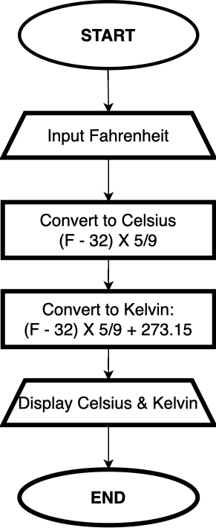

**Pseudocode**

The following pseudocode describes the logical flow of the temperature conversion process in a structured, plain English format.

1. Start the program.
2. Ask the user to enter a temperature in Fahrenheit.
3. Store the input as "Fahrenheit Temperature."
4. Convert the Fahrenheit temperature to Celsius using the formula:

* Subtract 32 from the Fahrenheit temperature.
* Multiply the result by 5/9.

1. Convert the Fahrenheit temperature to Kelvin using the formula:

* Subtract 32 from the Fahrenheit temperature.
* Multiply the result by 5/9. -
* Add 273.15.

1. Display the temperature in Celsius.
2. Display the temperature in Kelvin.
3. End the program.

**Desk Check Analysis**

The desk check below manually verifies the logic by testing the temperature conversion process with three different Fahrenheit inputs. The expected output is compared with the actual calculations to confirm the correctness of the formulas.

|  |  |  |  |  |
| --- | --- | --- | --- | --- |
| **Step** | **Fahrenheit Temperature (Input)** | **Celsius Calculation** | **Kelvin**  **Calculation** | **Expected**  **Output** |
| 1 | 100°F | (100 - 32) × 5/9 = 37.78°C | (100 - 32) × 5/9 + 273.15 = 310.93K | 37.78°C, 310.93K |
| 2 | 32°F | (32 - 32) × 5/9 = 0°C | (32 - 32) × 5/9 + 273.15 = 273.15K | 0°C,  273.15K |
| 3 | -40°F | (-40 - 32) × 5/9 = -40°C | (-40 - 32) × 5/9 + 273.15 = 233.15K | -40°C, 233.15K |

**Conclusion**

The structured approach used in this document demonstrates the process of designing a temperature conversion program using the Input-Process-Output (IPO) Chart, Flowchart, Pseudocode, and Desk Check Analysis. The appropriate formulas were applied to convert Fahrenheit to Celsius and Fahrenheit to Kelvin. The converted outputs were verified through a manual desk check, ensuring calculation accuracy. This process highlights the importance of software design methodologies in problem-solving, allowing for a logical and structured approach to program development.